A1125-Afr-Egy-Ushabti-Late Period-Plain Lappet wig with 2 bands-Plinth back-Hieroglyphs-Blue Faience

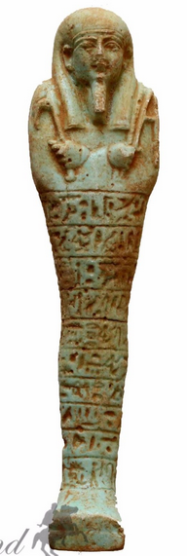 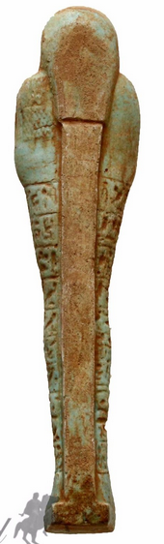

Figs. 1-2. Ushabti-Late Period-Plain Lappet wig with 2 bands-Plinth back-Hieroglyphs-Blue Faience

Case No.: 2

**Display Description**: This Ushabti of the Late Period has a Plain Lappet wig with 2 bands, plain plinth back-ten horizontal registers of hieroglyphs down the front and glazed in blue faience. The hands are crossed with sleeves with the right hand holding a holding a pick and the left holding a hoe.

Accession Number: A1125

LC Classification: DT62

Date or Time Horizon: Late period, 525-334 BCE.

Geographical Area: Saqqara, Egypt

Map, GPS Coordinates: 29.85000 31.21667; [29°52′16″N 31°12′59″E](https://tools.wmflabs.org/geohack/geohack.php?pagename=Saqqara&params=29_52_16_N_31_12_59_E_type:landmark)

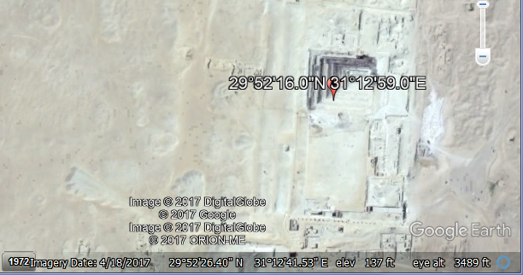

Cultural Affiliation: Late Period, Egypt, 525-334 BCE.

Geographical Area: Saqqara, Egypt

Medium: Blue Faience

Dimensions: H 143 mm, 5.62992 in; W 34 mm, 1.33858 in; D 23 mm, 0.905512 in.   
Weight: 85.57 gm,

Provenance: Stavros Nicolaides Alexandrou Papadiamandi 7020 CYPRUS, Larnaca Cyprus

**Condition:** origina**l**

**Discussion:**

**References:**